Title : MIYA the animal adoption application
Project Summary: "MIYA" will be implemented as an animal adoption application. We plan to identify and adopt the stray animals one by one with the support of its advanced map and downloaders. Animal owners in difficult situations will also have the right to collect donations by taking advantage of this application. When users enter the donation section, they will be able to view animals and their diseases. In addition, the profit obtained from the market section within the application will go to the drugs and veterinary team to be used for animals in distress. All you need to register an animal in the application is your smartphone and our smart collars. You can easily obtain these collars by scanning a QR code over a street lamp, and when you attach this collar to the animal you find and enter its information to register the animal, the animal you find begins to appear on the map. Our smart collars can be detected on the map within the application. Users who do not catch or touch animals can also reach our headquarters and call a team, or they can create an announcement by defining a point up to 2 kilometers from their current location and describing the animal together with the photos. If you find an injured animal, we immediately reach the headquarters and first respond to all injured animals with our veterinarian group. When people who want to adopt an animal find an animal of their choice, they can easily reach the animal thanks to our application after filling out the necessary forms and contracts. When the user uploads an animal to the application, the probability of winning a gift from our market increases thanks to our point system. With these actions, our goals are placing cats and dogs in a safe home to reduce overcrowding in shelters. We also plan to be a hope for animal owners whose animals are battling serious diseases such as FIP and Leukemia.

Keywords: MIYA, Animal Adoption , Animal , Adoption , Animal Adopt App , PetShop , Pet , Animal Help, Cat Adoption , Dog Adoption , Cat , Dog , Donate for Animals

- BACKGROUND RESEARCH & ACADEMIC SURVEY

The scope, limits and importance of the subject addressed in the project proposal are explained with qualitative or quantitative data as well as a critical evaluation of the literature.

In our project, there is a more advanced map system than the map feature of the "BiTaksi", which is a taxi transportation application.
In our application, we used an idea similar to the location of the scooters which you can see on the map of the "Martı" , which is an application for transportation by scooter. Thus, we will be able to see our smart collars on the maps inside our application.
The veterinary clinics we have contracted with will also be visible on our map and the ones close to the location will be shown.
By cooperating with applications such as "Yandex Maps" and "Google Maps", you will be able to get the transportation coordinates of the animals that appear on our maps.
Using your GPS location, you can see, feed or adopt animals near you from the nearby animals tab.
We have prepared a system similar to the advertisement system of the shopping site "Sahibinden". Thus, thanks to this application, people who cannot come into contact with animals will be able to enter the animals they see on the streets into the system.
Thanks to our application, we have offered an easier system to our citizens who want to collect donations for animals from various social media tools such as "Twitter" and "Instagram". We identified the animals for which needs help on social media and collected them all in our application. Thus, animal lovers will have the chance to see all of these animals which need of help on a single page and in a list and help one or all of them they want.
Smart collar technology will be able to be taken by scanning the QR Code, just like when reading the QR codes on Martı's.
If the person cannot catch the animal at that moment, in the process of releasing the leash, just like in the "Martı" application, by taking a photo of the collar and attaching it to the pole, the collar can be left on the pole.
We are inspired by the clothing registration applied in the "Dolap", firstly adding photos, then processing the information about the product into the system, and then adding the product to the system. Animal registration processes can also be completed by our users in this way.
We will check the advertised animals and their owners.

Inspired by the world wildlife fund "WWF", we will use the donation part of the sales revenues made famous by this brand to animals in our market section and donate the revenues.
While WWF concentrates the majority of its market donations on pandas, we will spend it on stray animals in need and their medicines.
Our market is in agreement with all cargo companies and will reach your door immediately with fast delivery.
In our market section, basic needs such as food, leash and cat litter will be able to be met, as in the "Getir" and "BanaBi" application.
The internal layout of the application will be similar to the "Dolap" application, with 5 buttons at the bottom and a button on the right corner, the only difference from the application that the rest will be covered by the map.

Aims and goals

The purpose and objectives of the project proposal are written in a way that is clear, measurable, realistic and achievable throughout the project.

My goal is convincing people to adopt animals by keeping them away from pet shops.
The dubious and bribe-filled parts of animal adoption from various social media will come to an end with our application, and everyone will be able to safely adopt an animal.
We will try to provide a safe environment by taking precautions against fake donors, most of which are made through social media tools.
An application concept that is unique in the App Stores and that I see it as a great shortcoming.
There will be a cat in the logo of the application and the general interface of the application will consist of yellow colors and tones.
We have thought of the process of earning a gift by earning points when you put an animal in order to encourage the users with both competition and gifts and to increase the active use in the application.
A shop with always fast delivery for pet owners.

- METHOD

The methods and research techniques (including data collection tools and analysis methods) to be applied in the project are explained with reference to the relevant literature. It is demonstrated that the methods and techniques are suitable for achieving the goals and objectives envisaged in the project.

The Methods section should cover the design of the research, dependent and independent variables, and statistical methods. If any preliminary work or feasibility has been made in the project proposal, they are expected to be submitted. Methods must be associated with work packages.

When you start the application, you will see 3 options. Sign-In button , Sign-Up button and Emergency button. When you click on the sign-up button, you enter your name, surname, number, home address, e-mail and the password you will set, and you request a code to be sent to your e-mail or number and you are directed to the menu after your account is confirmed. When you click on the sign-in section and enter your e-mail and password, if the password is incorrect, you are directed to the forgot password section. Once you verify your number and enter the code, you will be redirected to the system by changing the password. If you entered it correctly, you will be directed to the menu directly. If you press the emergency button, your instant location will be directed to our services and you will receive a notification that our system has been activated, and you will back to the main screen. When you switch to the main screen, a wide-ranging map opens with leashed animals and veterinarians. There are 5 buttons at the bottom of the screen and the profile button at the top right. When you enter the profile button, you can see and update your information, see the points you have earned and log out of your account. For animal registration press Button-1, you must scan the QR code of the collar when your camera is turned on. If you cannot catch the animal, you will be directed to Button-4. If you can catch it, you can put on the collar and photograph it and send it for approval along with the information of the animal. Once confirmed, the collar becomes active and can be viewed on the map. If it is not approved, the service is contacted. When the process is finished, it returns to the main menu. You enter button-2 to donate. When you click, a list of sick animals opens in front of you. If you want to collect donations, you write your information and send it for approval along with the information of the animal. Once approved, your animal is added to the list, and if it is not approved, you can contact us. If you want to donate, you can click to the donation section next to the sick animal. You should write the information of your card and amount which you want to donate, then send it. The application sends you a certificate via mail and you are directed to the main menu. When you click on button-3, a market appears in front of you. You can view your basic animal needs and our textile products from the market. If you want to shop, just drop the products in the shopping cart while browsing on the market, and when you click on the cart, you will be directed to the payment section after confirming your shopping. When you enter the payment information, your shopping is completed. If you have enough points which are gained with donations, and shopping you can use your points. After you receive a notification that the shopping was successful, you are redirected back to the main menu. If you don't want to shop, you can go back to the main menu. The function of Button-4 is related to animal adoption announcements and adoption processes. The list of stray animals opens in front of you, and you can view all nearby animals with or without a leash. If you know a stray animal that you cannot wear a collar, you can click the make an announcement button and wait for approval when you fill in the necessary information. Once approved, the animal will be visible in the list. If you want to adopt an animal, you can decide which animal you want by clicking the adopt button next to the animals. When you click on the adopt button, detailed information about the animal will appear. If you want to continue, you can click the continue button and fill in the necessary information and wait for approval. Once approved, you will receive an e-mail with the time and location where you will meet the animal. If you do not want that animal you have chosen, you can select a new animal by clicking the cancel button. When you click on button-5, a list of nearby veterinarians will appear which are listed on our map from near to far. When you double click veterinarian which is on list , it will direct you to that location with GPS apps.

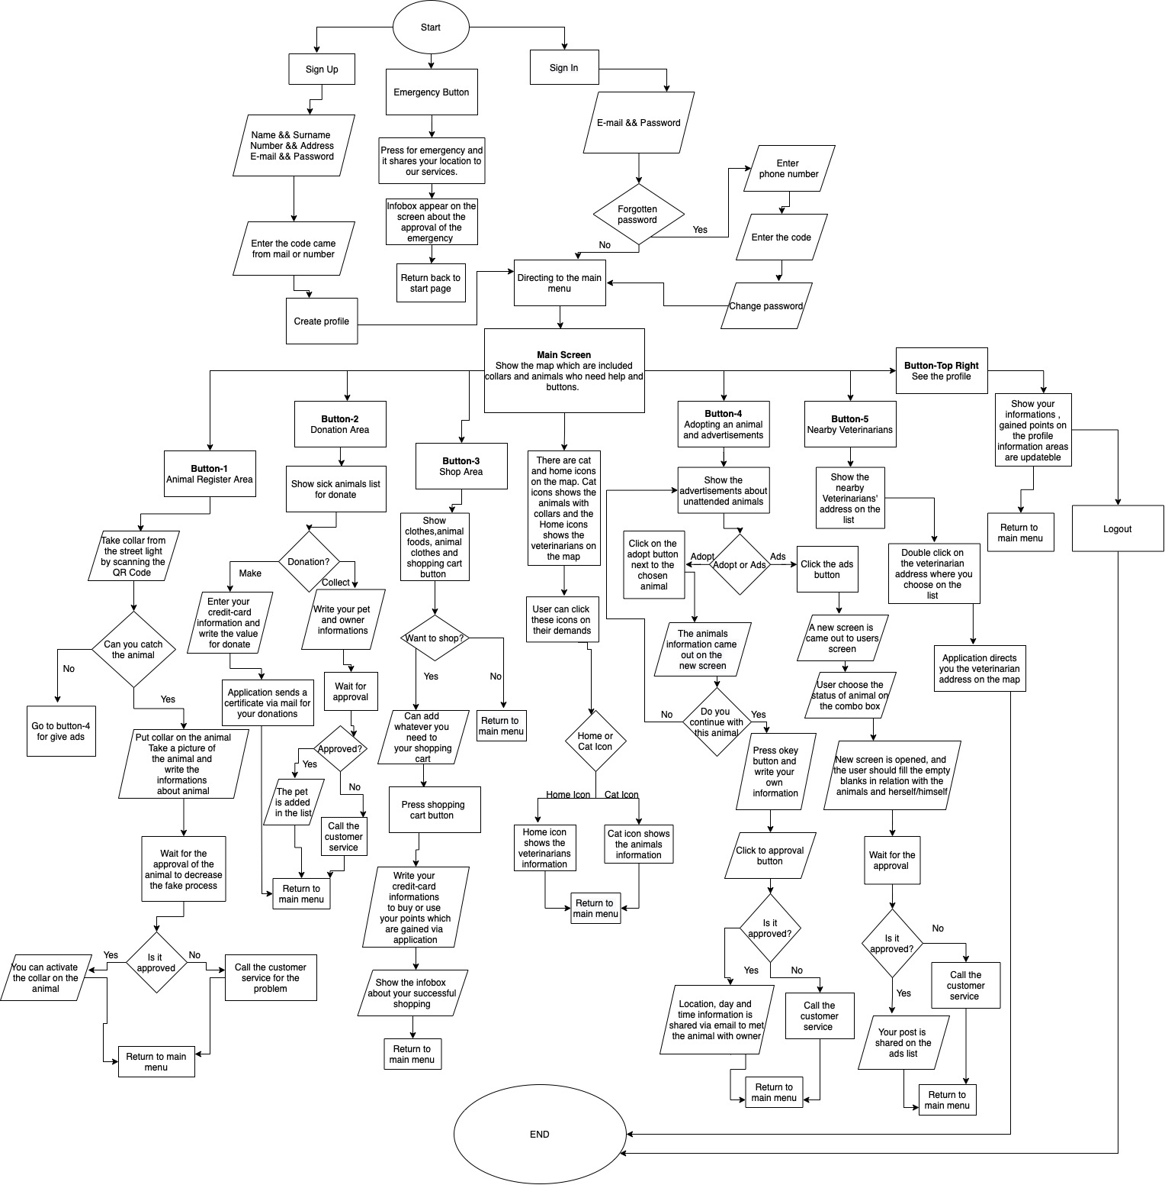
- PROJECT MANAGEMENT

  - Work Packages (WP), Task Distribution and Duration

3.1.1. Timeline

The duration of the main work packages to be included in the project is given by filling out the "Work-Time Schedule".

WORK-TIME SCHEDULE (*)

WP id* | WP Name* | The Importance of the success of the Project(%)** | MONTHS
WP id* | WP Name* | The Importance of the success of the Project(%)** | 1 | 2 | 3 | 4 | 5 | 6 | 7 | 8 | 9 | 10 | 11 | 12 | 13 | 14 | 15 | 16 | 17 | 18 | 19 | 20 | 21 | 22 | 23 | 24
101 | Animal_Register_Button | %14 |  |  |  |  |  |  | X | X | X
102 | Donation_Button | %10 |  |  |  |  |  |  |  |  |  |  |  |  |  |  |  |  |  | X | X
103 | Shop_Button | %14 |  |  |  |  |  |  |  |  |  |  |  | X | X | X
104 | Adoption_Ads_Button | %14 |  |  |  |  |  |  |  |  |  |  |  |  |  |  | X | X | X
105 | Nearby_Vet_Button | %10 |  |  |  |  |  |  |  |  |  | X | X
106 | Map_and_Banners | %16 |  |  | x | x | x | x
107 | Login_Screen | %10 | X | X
108 | Profile_Button | %12 |  |  |  |  |  |  |  |  |  |  |  |  |  |  |  |  |  |  |  | X | X | X

(*) The rows in the chart can be expanded and multiplied as needed.
(**) The column total must be 100.

  - Risk Management

The risks that may adversely affect the success of the project and the measures to be taken to ensure the successful execution of the project when these risks are encountered (Plan B) are outlined in the Risk Management Table below by specifying the relevant work packages. Possible risks related to the research question and/or hypothesis of the project are taken into consideration. The implementation of plan B should not deviate from the core objectives and original value of the project. If there is a method change in case of switching to plan B, this situation should be detailed. Work packages for which no risk is foreseen are not included in this section.

WP ID* | Definition of Risk(s) | Action(s) to be Taken (Plan B)
1 | Fake Animal Owners and Registers | Video calls can be made with the animal and its owner in need through the system before suspicous approval.
2 | Not being able to catch the animal that needs help | Advertise via button-4 and check the animal you advertise every day and contact the system so that it can be put on a collar.
(*) Rows in the table can be expanded and multiplied as needed.

